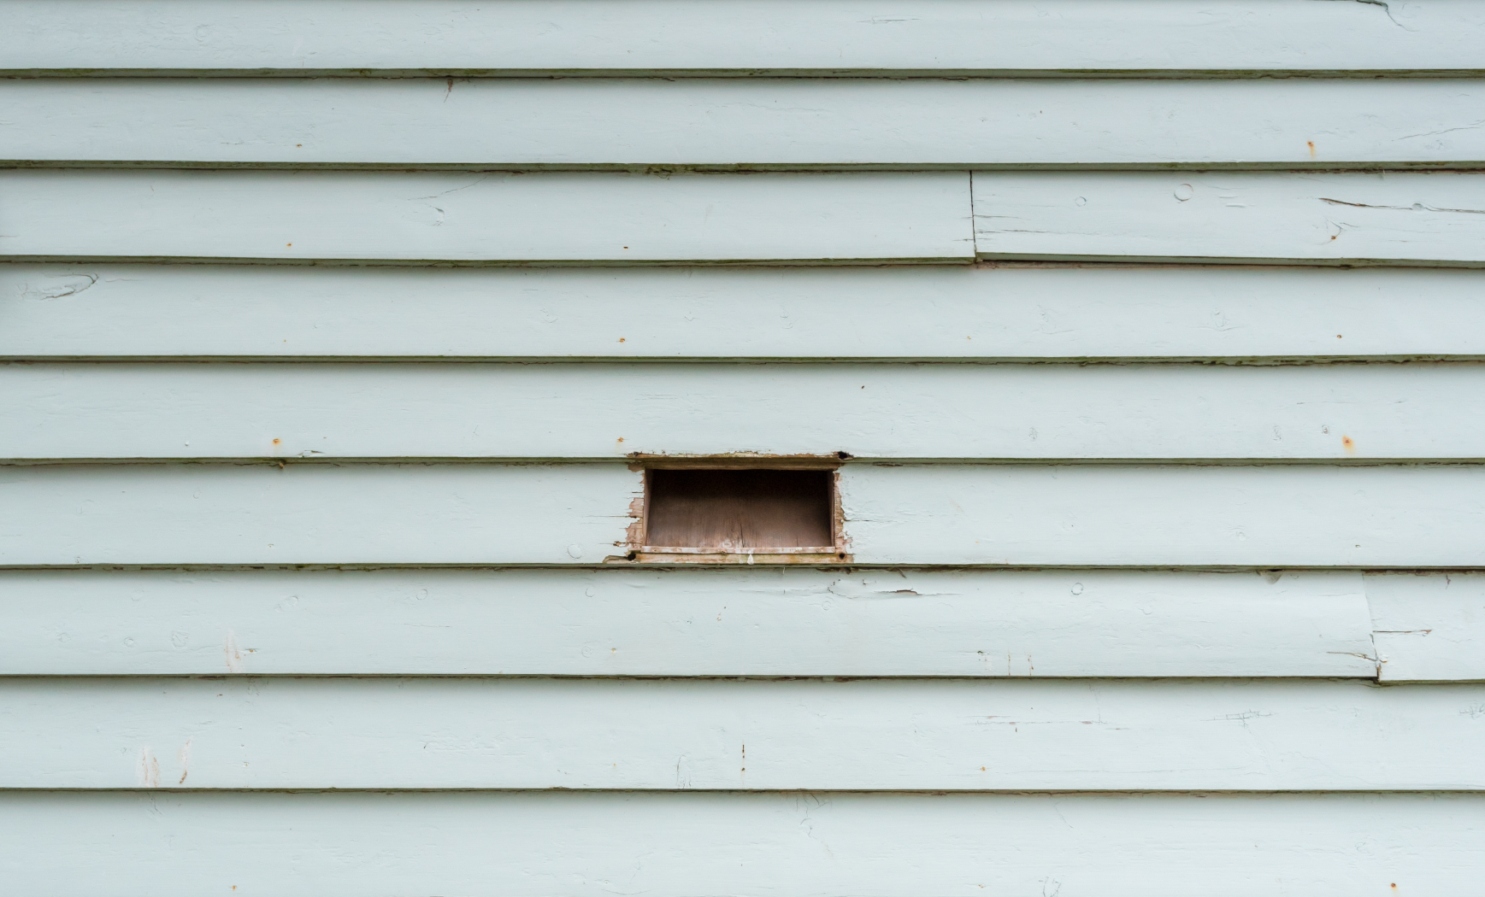
Finding
Byaduk
As someone relatively new to Australia, and in particular regional Victoria, the encounter with Byaduk is something I relate to as a moment of peaceful experience. This perhaps is not too surprising, coming from the perspective of a metropolitan dweller, but I feel like there is more to this than the story of the city mouse and the country mouse.

Part of this proposed residency relates to how we respond to new environments, a study in phenomenology and how our experiences in turn shape the way we understand the world we live in. There are sensory encounters of the landscape to explore – sunlight on the paddocks and in empty rooms, the sounds of leaves and pine needles in the wind, the roar of vehicles on the road, the occasional farm animal. Stories might also be found in the smaller things – cradle roll certificates in the Old Byaduk Church, re-used workbenches, paintings, moss, firewood stacks. In a way the residency can be seen as a refiguring of the curated stories on placards presently located around Byaduk, an investigation into the material culture of Byaduk. The story of the bridge and the builder’s toolbox, the old swimming pool’s and how much it used to cost for the now-unknown things on the deteriorated signs are but a few. We often wonder why these precious little things in our past are important. The project proposal is inspired by these gestures, the poetry of minute details that give meaning to life.

My creative practice has its roots in digital media and speculative investigations of its consequences and interactions with the tangible, physical world. This also forms the larger picture of the themes I am currently researching in my creative practice PhD. I see the project as a continuation of this practice.

This is an artistic interpretation of the stories of Byaduk, not necessarily as memories locked and sealed away in time, but that of an exploration where live, digitised sensor streams of Byaduk’s environmental effects dynamically shape the output of a series of kinetic, sculptural objects crafted for the residency.

Seen in this light, the project can be understood as one that transforms effects into affective gestures, and in the process hoping to bring to view moments of Byaduk for those who hold fragments of it.

I would like to create living artefacts of Byaduk – small, interactive sculptural forms that ‘connect’ to Byaduk with the help of digital and electronic media. The way these objects connect to Byaduk is through the sensor feeds that will be installed in and around the Old Byaduk Church (refer to the next section below for details).

The residency proposes to install a series of minimally-intrusive environmental sensors in Byaduk to facilitate this project. This also means there will be two distinct phases of the residency:

Phase 1: ‘Listening’
Installation of a series of customised sensors in the Byaduk Old Church.

Phase 2: ‘Expressing’
Crafting of artefacts that express the above-measured quantities and qualities of the listening sensors

The following portions detail the type of work that will happen in each phase.

Implementation

Phase 1: ‘Listening’
These environmental sensors listen in to the conditions around the church, providing answers to:

What is the colour of the sky in Byaduk?
How hot, or cold, is the small courtyard?
How intense is the sun?
Is the palm tree swaying, or as still as I remember it?
Did someone just drive through the town?

The listening is specific to the landscape. It is both natural, and human-driven. receiving gestures from nature, the activities that surround Byaduk.

The types of sensors will consist of the following equipment, grouped by their sensing attributes and proximity to their sensing targets:
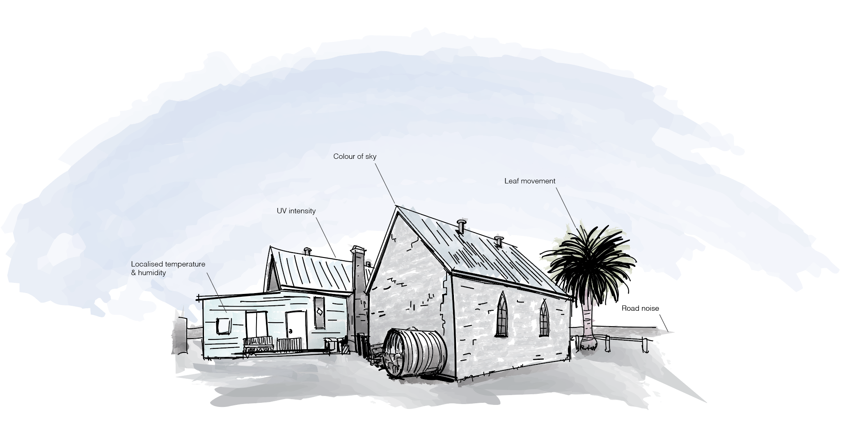

SUNLIGHT
Spectrometer
UV sensor

TEMPERATURE
Temperature &
Humidity sensor

MOVEMENT
Tree movement - microphone
Passing traffic - microphone

The Old Byaduk Church will play a central role, serving as a repository through which the sensors will connect to, re-living the communal role it has played in the past for the town and the surrounding local area. A server about the size of a small lunchbox will be installed to consolidate the digitised sensor readings. Instead of reaching out to people directly, it now plays its role through an ephemeral digital network, as it quietly listens and relays a stream of locally-connected data to the connected objects.

Power-wise, I would like for these sensors to run mostly off the grid. The use of solar power and batteries is proposed to allow the relatively low-powered sensors to operate continuously.

Phase 2: ‘Expressing’
From these sensors, a perpetual stream of digital readings will be broadcast to a server. It is through this data stream that the second half of the creative output will emerge – the crafting of ‘data artefacts’ that embody and channel the environmental and general phenomena of Byaduk; tangible objects that bring to our mind the place and condition that is Byaduk. Like a message in a bottle, these artefacts are intended to exist as domestic objects, beacons that live on in homes away from Byaduk. Through these objects, we find Byaduk; through the experience of these objects, fragments of a place are kindled and nurtured.

The artefacts themselves will be crafted using a combination of materials sourced from Byaduk, and of others that present a resonance with the type of data that it will express.

In my initial visits to the Old Byaduk Church and the vicinity, I have observed a number of features that might contribute to the thinking on materials to be used for the artefacts.
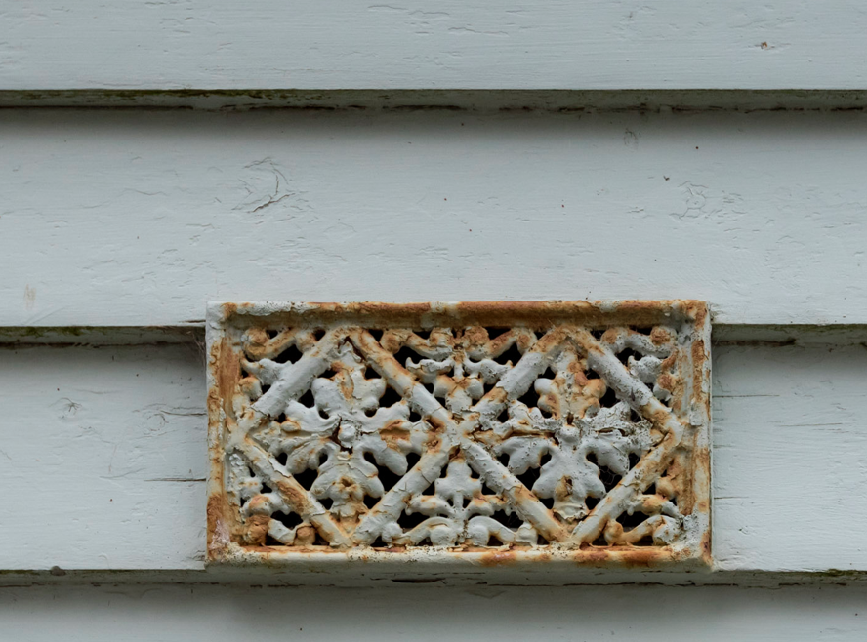
This ventilation grille outside of the church hall, mounted on the wall along, sits silently with another that hangs precariously, while another has dropped off completely. I like how the various conditions of the grilles represent the way we find, live, and eventually depart from places.
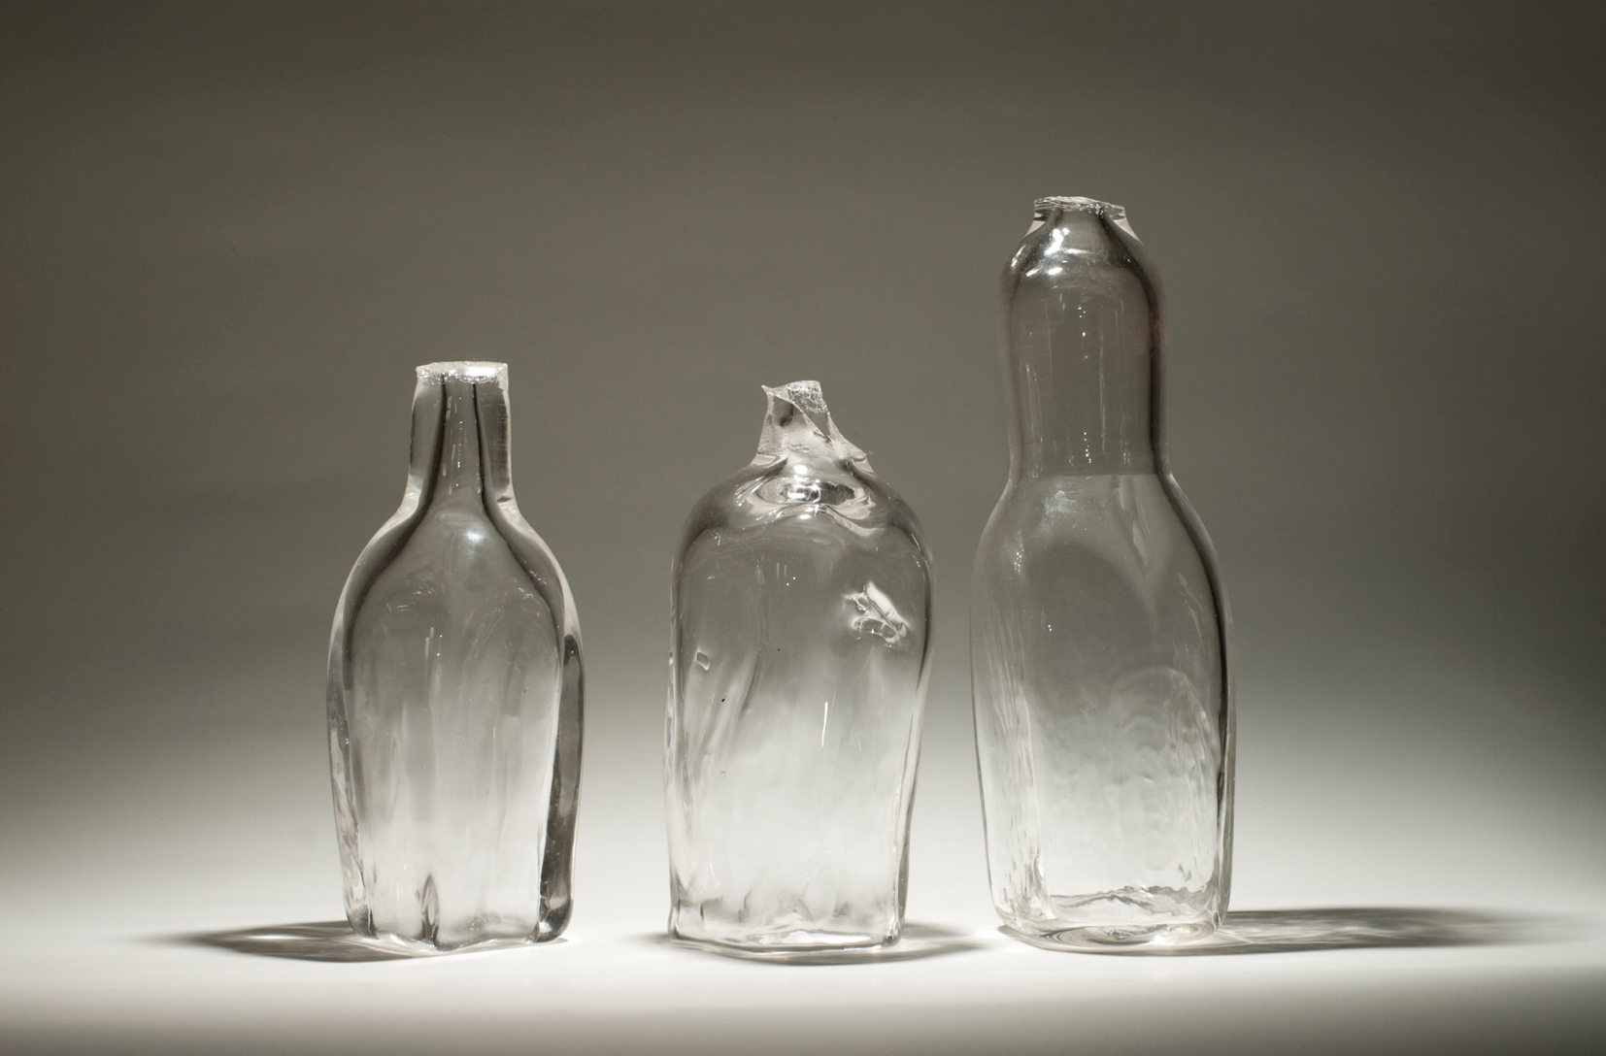
These glass ‘bottles’ were my first attempt at blowing glass. It is obvious that they leave much to be desired appearance-wise. They came to mind because they represented a moment of discovery and the experience of something new. At this point these objects serve as speculations and thinking towards the second phase.

These objects will be crafted in a way that interactions and human input are part of its design. These will all become part of the evolving creative process that explores the matrix of digitised sensor feeds from Phase 1.

Finally, the artefacts are to be documented as a series of writing, videos and photographs on a website in their final ‘homes’, and the lives that they ‘lead’ will serve as a crucial conclusion to the project.

Engagement with Community

The way in which the artefacts are crafted will tap on the history and culture of Byaduk. Some of these places could involve ethnographic field studies – observations, interviews, and finding ways to record and transmit these affective moments, providing another means to understand and channel the thoughts and dreams of Byaduk.

Future directions

The project has the potential for a sustained art practice, given that the 2 key phases allow future opportunities for other projects and collaborations to engage with the same data feeds. In that light, I would also like to propose the possibility of future teaching studios in the second semester of 2018, where students contribute to the Finding Byaduk project through the making of more ‘data artefacts’. Details can be found in the proposed schedule linked below.

A non-artistic aspect of this project that is intentionally set aside for the time being is the possibility for further explorations into the nature of data, particularly the use of learning algorithms to analyse data patterns. This could possibly stretch towards more typical use-case scenarios of data analytics projects, and may benefit the local community in more practical ways. Being a creative practitioner working between both art and design, this could present a longer-term opportunity to leverage the technology implemented in this project to discover newer forms of artistic practice – one that considers both data and landscape as coplanar materials.

Proposed schedule, Project cost estimates (Google Sheets): removed

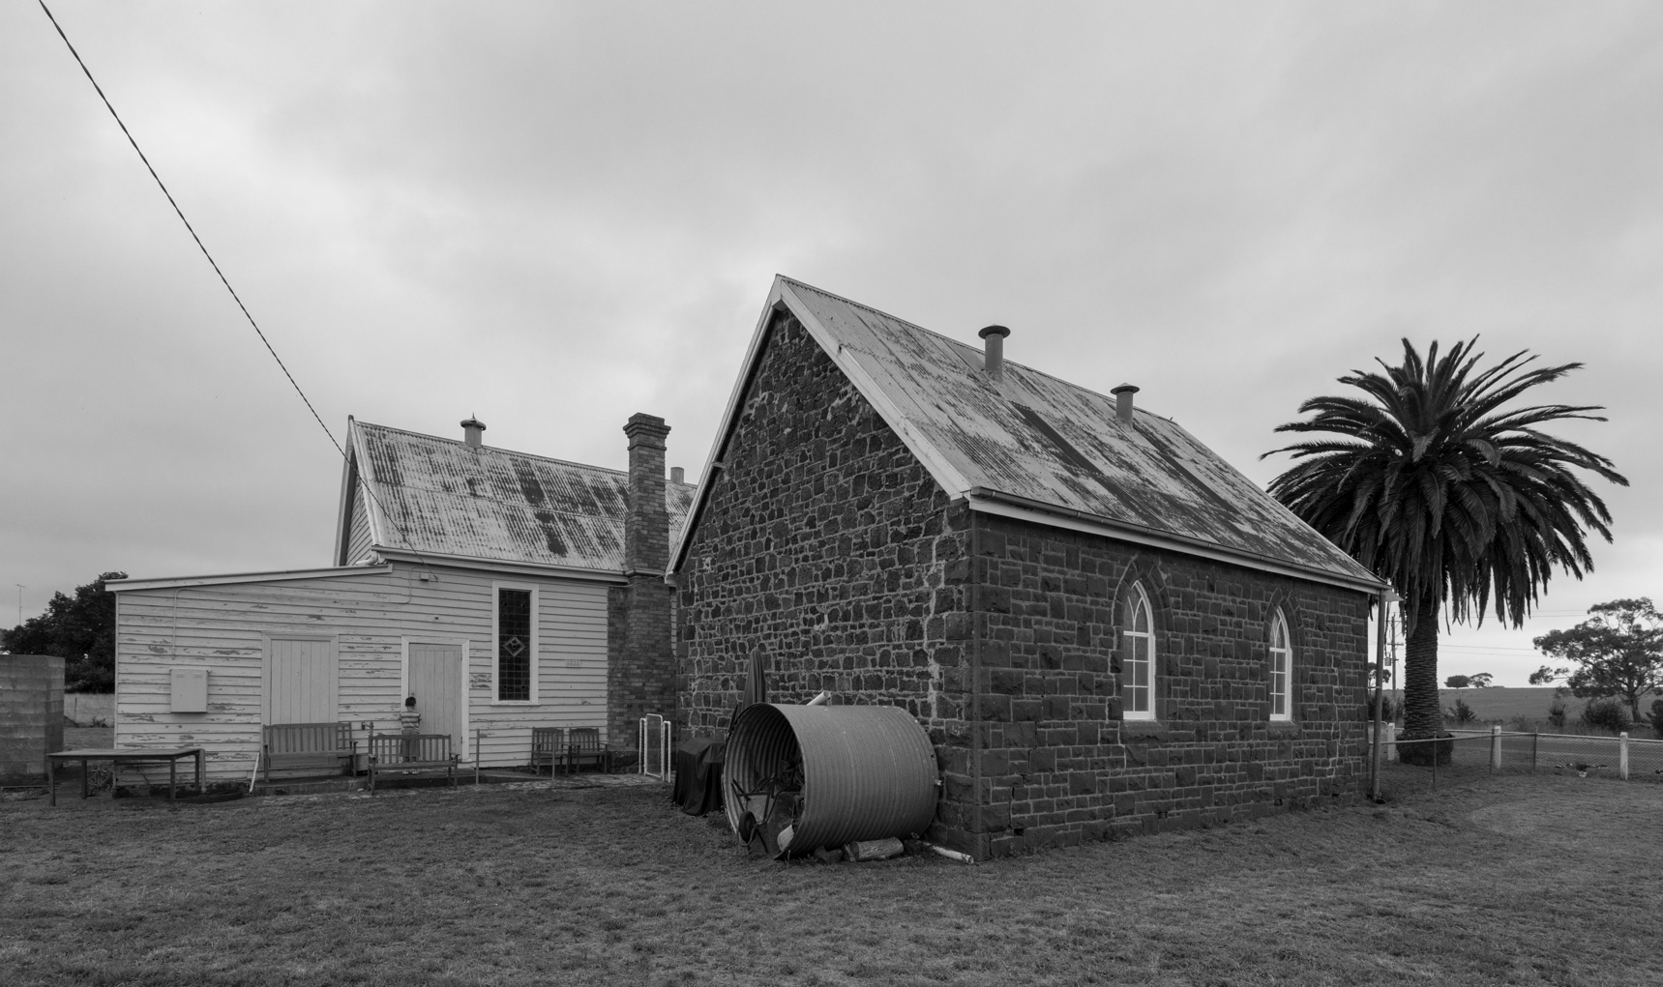
– Chuan Khoo

